Cloud Security Experiment Instruction Manual
Step 1: Setting Up the Azure Experiment Environment (Super Detailed Guide)
1.Goal: Create an Azure Virtual Machine (VM) as the test environment and enable Microsoft Defender for Cloud to monitor security threats automatically.
2 Expected Outcome: Successfully set up a Windows Server 2019 VM in Azure, with Defender for Cloud enabled for security monitoring. This will serve as the foundation for attack simulation and automated response testing.
A. Creating an Azure Virtual Machine (VM)
Tools Required:
- Azure Account (Free trial or existing subscription)
- Azure Portal (https://portal.azure.com)
Step-by-step Guide:
1️ Log into Azure Portal
- Open your browser and go to Azure Portal.
- Enter your Microsoft account credentials and log in.
  - If you don’t have an account, sign up for a free trial account with Azure.
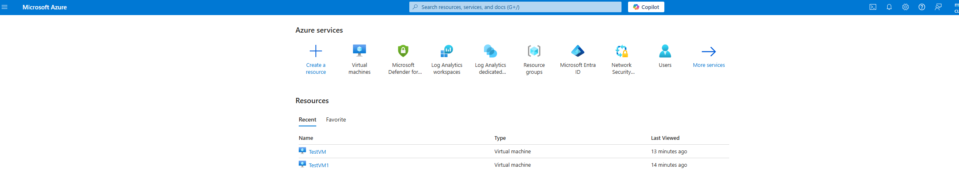
2️ Create a Resource Group
- What is a Resource Group?
A Resource Group is a container in Azure where all related resources (such as VM, network, security policies) are managed together.
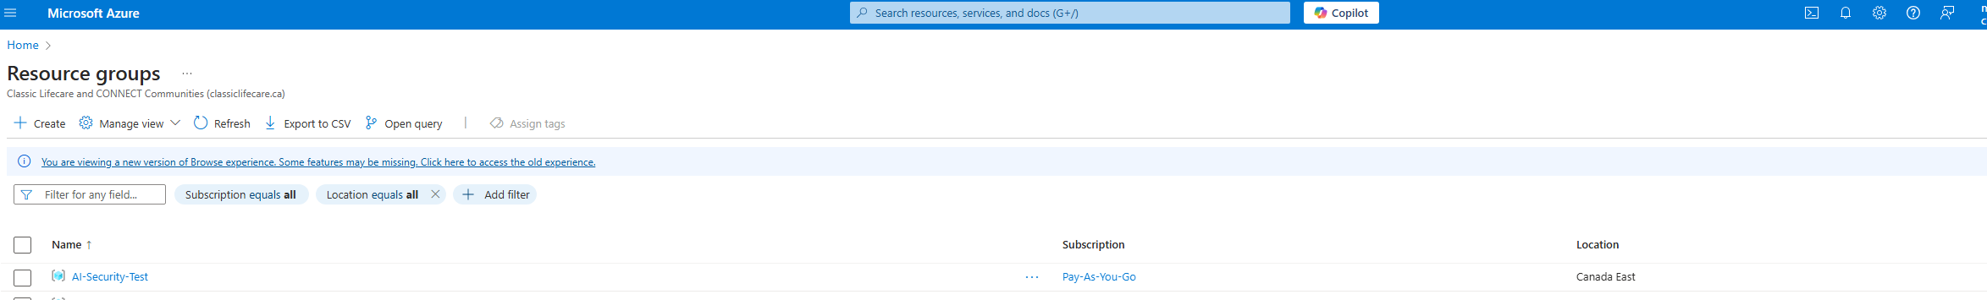
- Steps to Create a Resource Group:
- In Azure Portal, go to the left menu and click "Resource Groups".
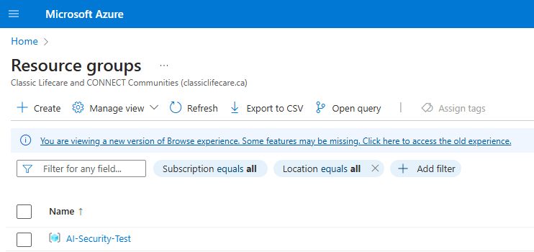
- Click "Create".
- In the Subscription field, select your Azure subscription (e.g., Free Trial).
- In the Resource Group Name field, enter:
- AI-Security-Test
- Choose a Region:
  - Select the nearest Azure data center (e.g., East US or West Europe).
- Click "Review + Create", then click "Create".
Once the resource group is created, all Azure resources (VM, network, security settings) will be managed under this group.
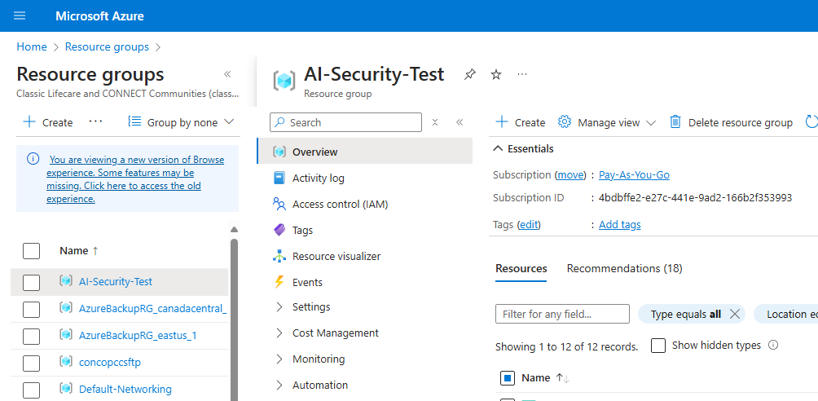
3️ Create a Virtual Machine (VM)
- What is the VM Used for?
The Virtual Machine (VM) serves as the test target, simulating a real cloud environment where AI will monitor security threats.
- Steps to Create a VM:
- In Azure Portal, go to the left menu and click "Virtual Machines".
- Click "Create" > "Azure Virtual Machine".
- In the Basics section, configure the following settings:
Setting | Configuration
Subscription | Select your Azure subscription.
Resource Group | Choose AI-Security-Test
Virtual Machine Name | Enter TestVM
Region | Choose East US (or another preferred region)
Image | Select Windows Server 2019 Datacenter
Size | Choose Standard_B1s (low-cost test environment)
Administrator Username | Enter azureuser
Administrator Password | Enter TestPassword123! (Remember this password)
Once completed, click "Next" to proceed.
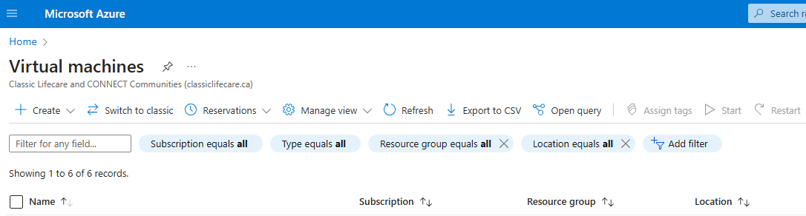

4️ Configure VM Networking
- Why Configure Networking?
- Allow Remote Login (RDP) to access the VM and perform tests.
- Allow network traffic (Ping & Port Scanning) to simulate attacks for Defender for Cloud to detect.
- Steps:
- Go to the "Networking" tab.
- Ensure the following settings:
Setting | Configuration
Virtual Network | Select AI-Security-Test-vnet (auto-generated)
Subnet | Default setting
Public IP | Select Enabled
Inbound Port Rules | Choose Allow selected ports
Select Inbound Ports | Check RDP (3389) and SSH (22)
Ensuring RDP (3389) and SSH (22) are enabled allows remote access for testing.
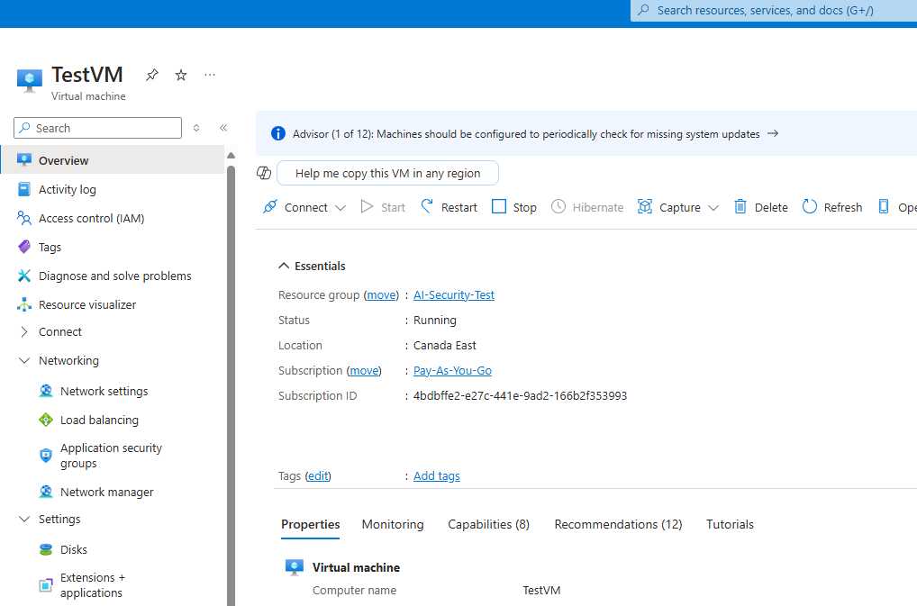
5️ Configure Security Settings
This step prepares the VM for Defender for Cloud to monitor threats.
Steps:
- Go to the "Management" tab.
- Configure the following:
  - Monitoring: Enable Boot diagnostics (for logging).
  - Identity Management: Keep default settings.
  - Azure Security Center (Defender for Cloud):
    - Enable "Microsoft Defender for Cloud" to monitor security threats.
Once Defender for Cloud is enabled, it will automatically detect security incidents.
If you want to confirm that Defender also monitors TestVM, you can try the following:
1️Go to Microsoft Defender for Cloud
Navigate to Inventory to see if TestVM is listed in the protected resource.
If TestVM is displayed as "Monitored" or "Protected", Defender is already monitoring!
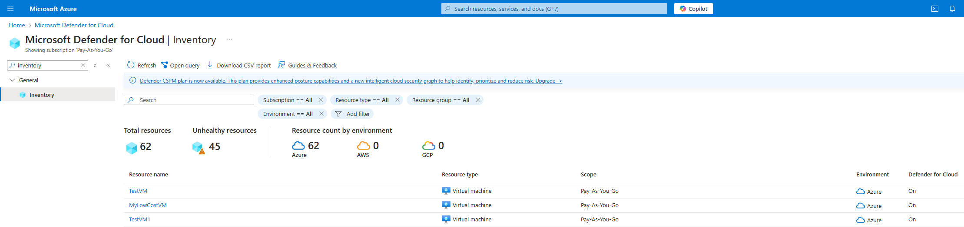

6️ Review and Create the VM
- Final step before deployment.
- Steps:
- Click "Review + Create".
- Double-check all settings.
- Click "Create" to start the deployment.
- Wait 2-5 minutes for Azure to deploy the VM.
Once deployed, the VM is ready for testing!
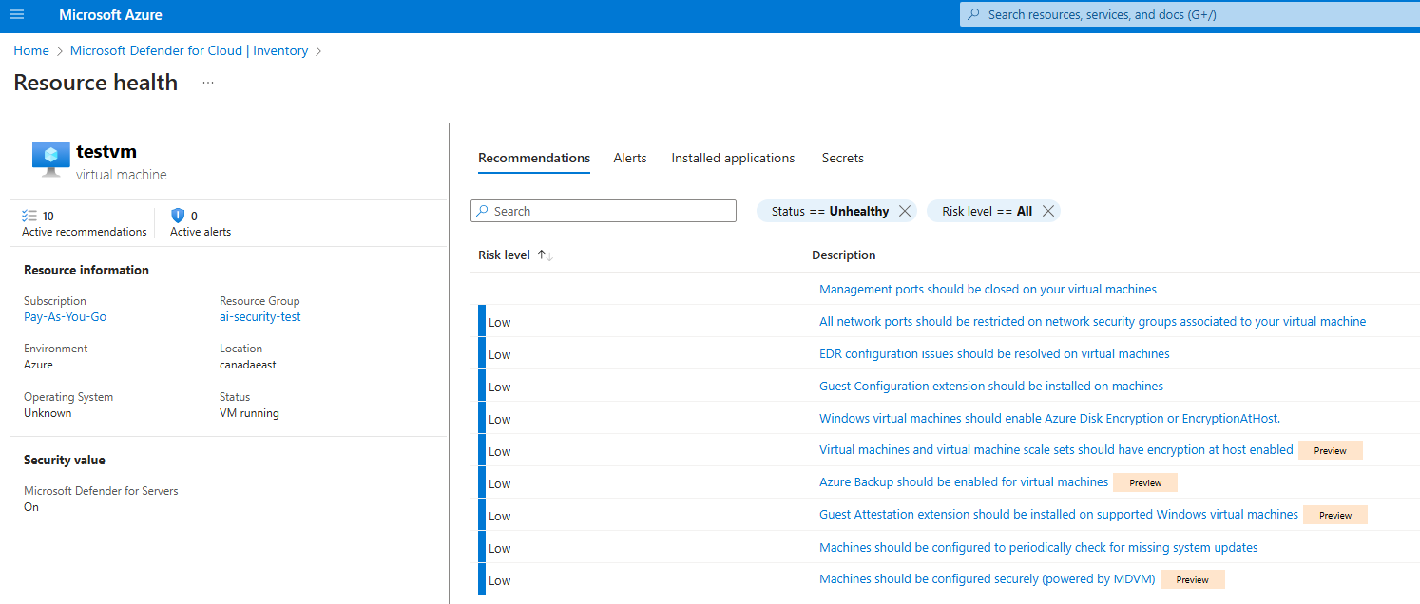

B. Connecting to the Azure VM (Remote Desktop Access)
- Goal: Ensure remote access to the VM for attack simulations and AI monitoring.
- Steps:
- In Azure Portal, go to "Virtual Machines" and find TestVM.
- Click "Connect" > "RDP" (Remote Desktop Protocol).
- Download the RDP connection file, then double-click to open.
- Enter the Username & Password:
  - Username: azureuser
  - Password: TestPassword123!
- Once logged in, you will see the Windows Server desktop, where you can perform the experiment.
If RDP fails, check if Azure allows RDP (3389) traffic.
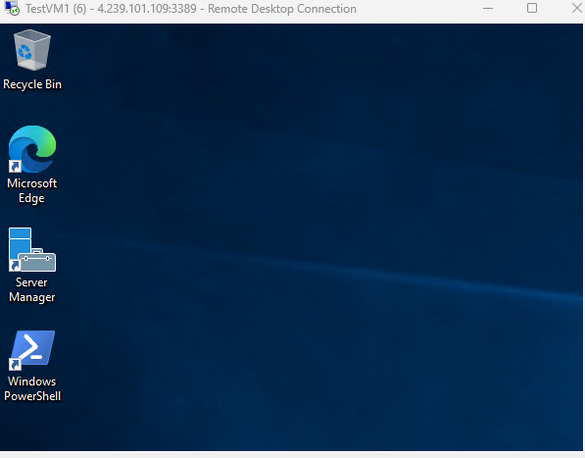
C. Enabling Microsoft Defender for Cloud
Goal: Enable AI-powered threat detection to monitor the VM for security incidents.
Steps:
- In Azure Portal, click "Microsoft Defender for Cloud" on the left menu.
- Navigate to "Environment Settings", find TestVM.
- Click "Enable Defender for Cloud", then activate:
  - AI Threat Detection (to monitor for attacks).
  - Log Collection (for later analysis).
- Wait 10-20 minutes for Defender for Cloud to start monitoring the VM.
Once enabled, Defender for Cloud will record and detect all suspicious activities.

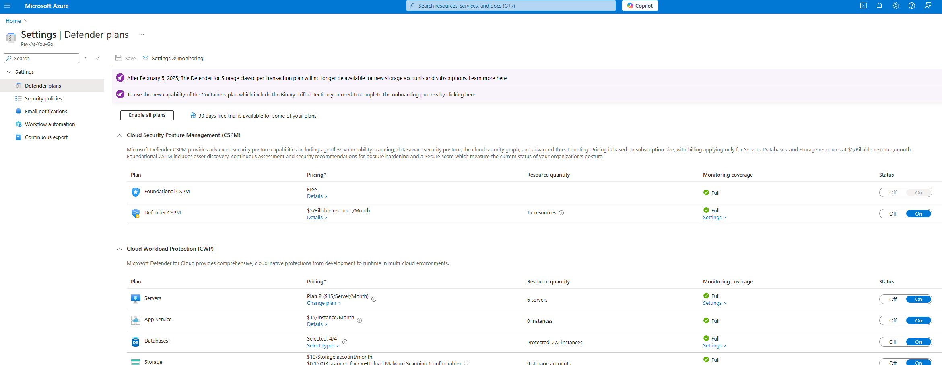

Make sure the Defender program covers TestVM and that all protection levels are enabled.
procedure
1. Go to Azure Portal > Microsoft Defender for Cloud
2. Click on the left menu "Environment Settings" under the "Pay-As-You-Go" subscription, check "Defender Plans Coverage"
Check whether it is "Full Coverage".
If not fully covered, click on "Manage Plans" and enable all protection features:
✅ Defender for Servers
✅ AI Threat Detection
✅ Log Analytics
✅ Just-in-Time Access
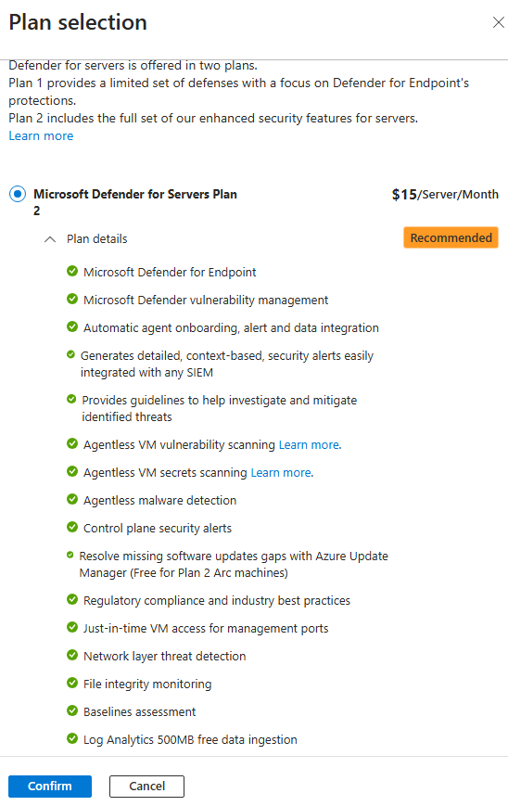
At this point, Step 1 is completed, and your experiment environment is ready!
Now, we can proceed to Step 2 – Simulating Attacks to Trigger AI Security Monitoring!

Step 2: Simple and Easy-to-Execute Simulated Attack Experiment Steps
Objective:
- Trigger Microsoft Defender for Cloud to detect security incidents and generate alerts.
- Observe whether Defender can detect abnormal behaviors.
- Designed for users without a cybersecurity background; easy to follow step-by-step.
Step 1: Preparation
Ensure the following conditions are met:
1️. TestVM is protected under Defender for Cloud
- We have already completed this step ✅
2️. Azure account has sufficient permissions
- Here need "Security Admin" or "Defender Security Reader" role.
3️. RDP remote access to TestVM is working
- If you can connect via RDP, proceed to the next step.
- If you cannot connect, check Azure Network Security Group (NSG) rules to ensure port 3389 is temporarily open.
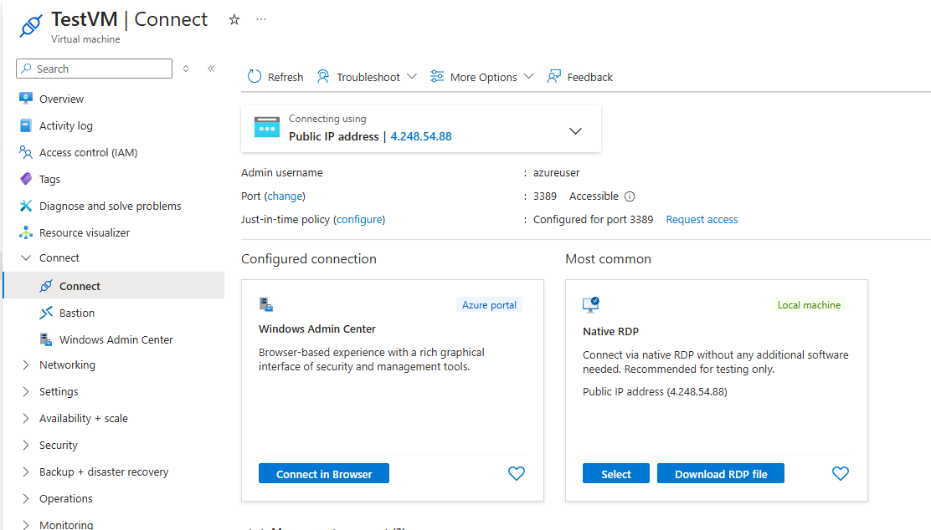
Step 2: Simulating a Port Scanning Attack
Purpose:
Use simple port scanning to simulate an attacker searching for open ports, testing whether Defender can detect this activity.
Execution Steps
Method 1: Scan TestVM from Your Local Computer
- Open PowerShell on your local computer (Windows).
- Run the following commands to scan common ports on TestVM:
- Test-NetConnection X.XXX.XXX.XXX -port 3389
- Test-NetConnection X.XXX.XXX.XXX -port 22
Azure blocks all master traffic by default unless it is manually cleared. Therefore, if False is displayed at this step, you must log in to Azure Portal and set it manually.
On the left side of Azure Portal, click Virtual Machines.
Select TestVM.
3️ Open the "Networking" TAB:
In the left menu, click "Networking".
Find "Inbound Port Rules".
4️ Check whether there is a port 22 rule:
If there is no 22 (SSH) rule, click "Add inbound port rule".
The configuration rules are as follows:
Source: Any
Source port ranges: *
Destination: Any
Service: SSH
Destination port ranges: 22
Protocol: TCP
Action: Allow
Priority: 1000 (default)
Name: Allow-SSH
5️ Click the "Add" button to save the rule.
6️ Wait a few minutes, then run again

If the test fails, connect to TestVM and open PowerShell ISE and run the following command to make sure OpenSSH Server is installed
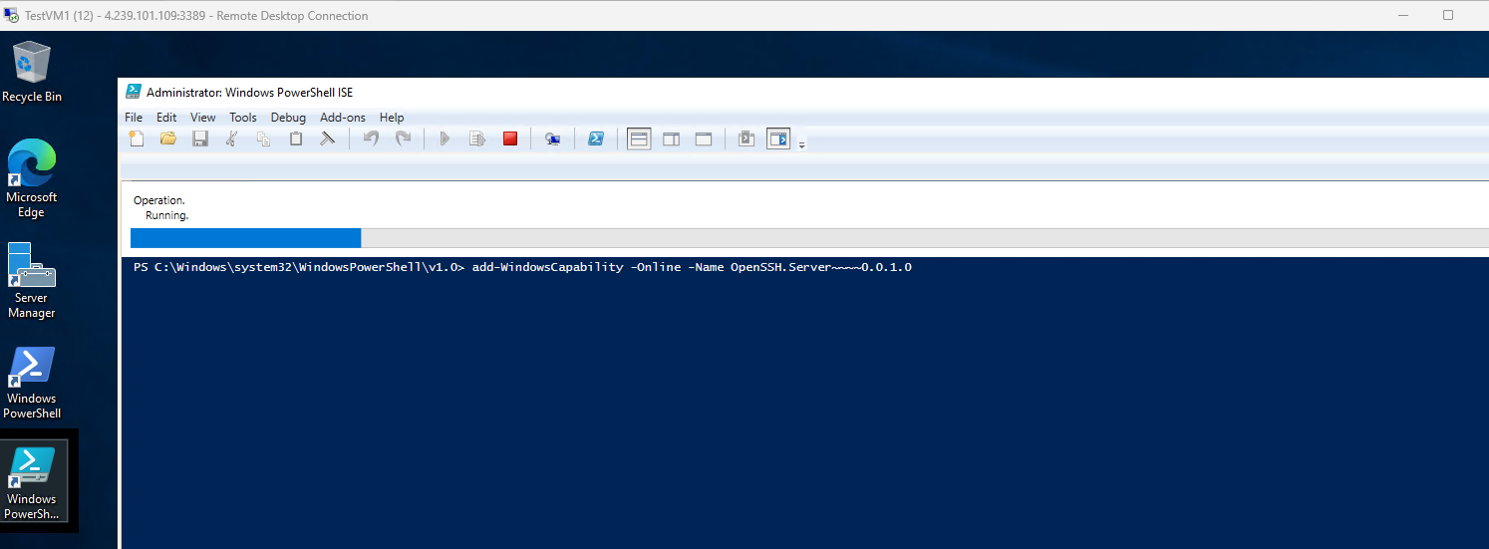
Or :
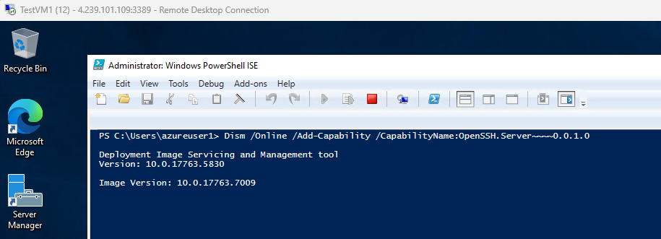
On the left side of Azure Portal, click Virtual Machines.
Select TestVM.
3️ Open the "Networking" TAB:
In the left menu, click "Networking".
Find "Inbound Port Rules".
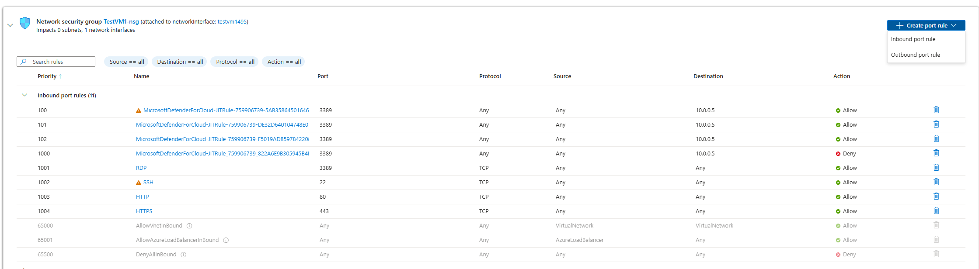
4️ Check whether the port 443 rule exists:
If the 443 (HTTPS) rule is not available, click "Add inbound port rule".
The configuration rules are as follows:
Source: Any
Source port ranges: *
Destination: Any
Service: HTTPS
Destination port ranges: 443
Protocol: TCP
Action: Allow
Priority: 1000 (default)
Name: Allow-HTTPS
5️ Click the "Add" button to save the rule.
6️ wait a few minutes, then re-run test-netconnection to Test:
  - If the port is open, the result will show "TcpTestSucceeded : True".
  - If the port is closed, it will return "False".
Please use the TestVM Public IP instead of the example 4.239.101.109
Method 2: Scan Ports Internally from TestVM
- Connect to TestVM via RDP.
- Open PowerShell inside TestVM.
- Run the following command to scan all local ports:
- for ($i=1; $i -le 65535; $i++) {
- Test-NetConnection -ComputerName localhost -Port $i
- }
  - This command will scan all ports, simulating a local network scan tool.
  - If Defender detects abnormal activity, it should generate a security alert.
Step 3: Simulating an SSH Brute-Force Attack
Purpose:Simulate an attacker attempting to brute-force SSH access by entering incorrect credentials multiple times.
Execution Steps
- Open PowerShell on your local computer (Windows).
- Run the following command to attempt SSH login to TestVM (if SSH is enabled):
- ssh fakeuser@<TestVM Public IP>
  - If SSH is not enabled, it will return "Connection refused".
  - If SSH is enabled, try entering an incorrect password multiple times:
  - ssh azureuser@<TestVM Public IP>
    - Enter a wrong password like "wrongpass" about 5-10 times.
  - Defender may detect the failed login attempts as a brute-force attack and trigger an alert!
Step 4: Check for Security Alerts in Microsoft Defender for Cloud
- Go back to Azure Portal > Microsoft Defender for Cloud.
- Click "Security alerts" on the left menu.
- Check if any new alerts have been triggered, such as:
  - Port Scanning Detected
  - Brute-force Attack Detected
  - Suspicious Login Attempts
- If no alerts appear immediately, wait for 10-15 minutes and refresh the page.
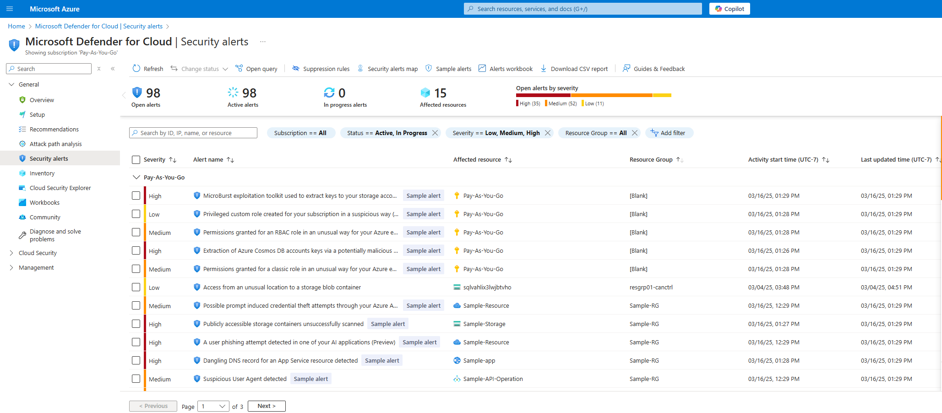
Virtual machines ports 3389 access
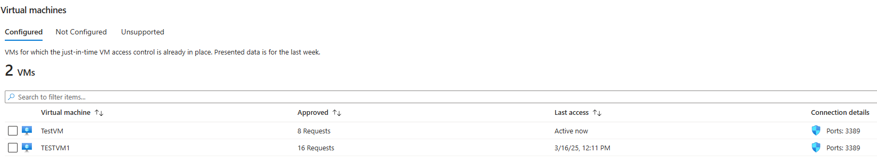

Test VM1 Alerts
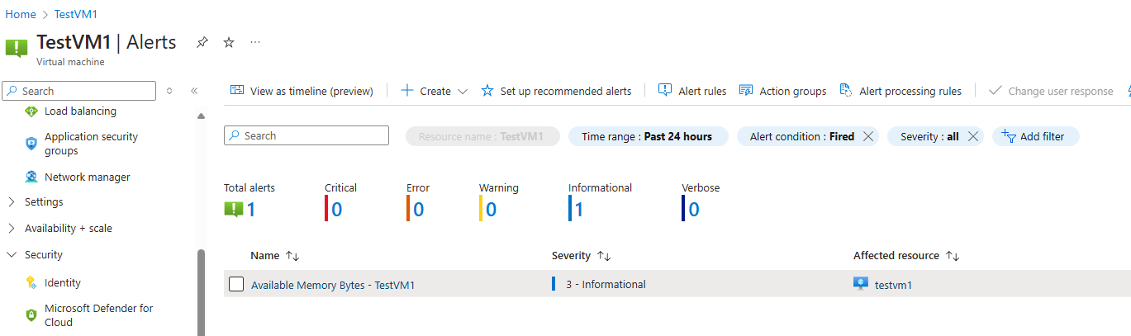
Security alerts map
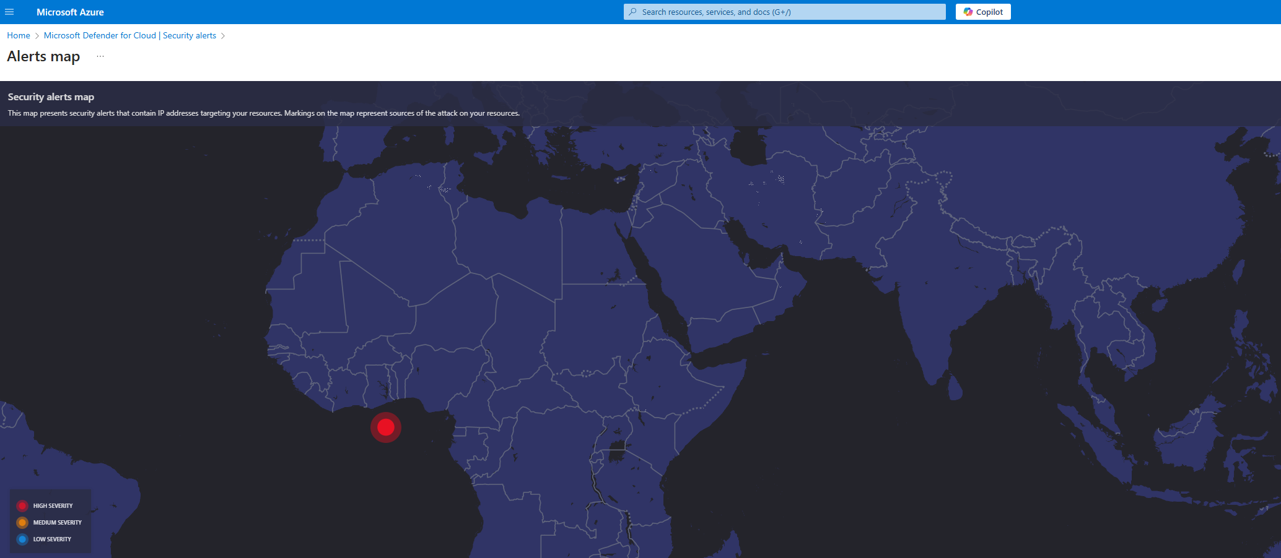
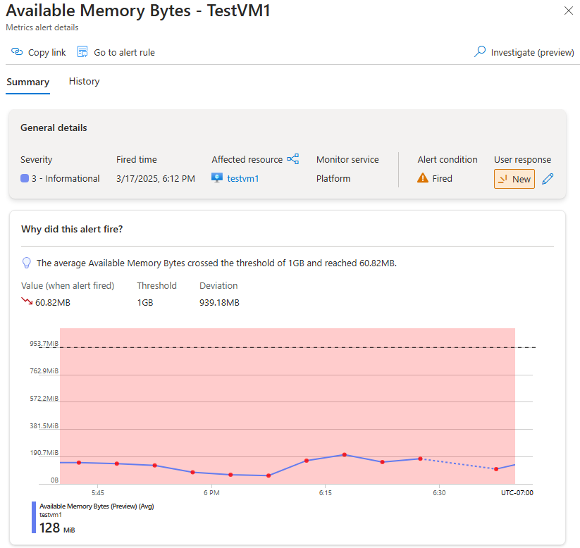
Test VM have a vulnerability assessment solution
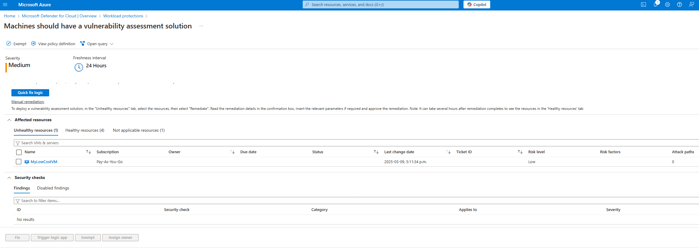
Step 3: To collect security logs
Step 4: AI automatically responds to security incidents
Use Power Automate to create a self-healing security system that automatically blocks threats.
🔹 Tools Required: Power Automate (Microsoft Flow)
Steps:
- Open Power Automate (https://flow.microsoft.com).
- Click "Create a new Flow" > "Automated cloud flow".
- Trigger Condition:
  - Select Microsoft Defender for Cloud as the trigger source.
  - Set the trigger "When a high-severity alert is detected".
- Action 1: Block Suspicious IP Address
  - Add a new action: "Create a Firewall Rule" (Azure Firewall).
  - Configure the rule to block the IP address associated with the attack.
- Action 2: Notify Security Team
  - Add an action: "Send an email notification".
  - Notify an administrator whenever an attack is detected.
- Enable Flow and Test the Automation.
Step 5: Analyze AI Security Response with Power BI
Goal: Visualize security incidents and measure AI’s effectiveness.
Tools Required: Power BI
Steps:
- Open Power BI Desktop or Power BI Web.
- Import Azure Defender security logs (export CSV from Azure Security Center).
- Create dashboards to analyze:
  - Number of detected threats over time.
  - Number of AI-automated responses.
  - Most common security alerts.
  - Time saved by AI automation vs. manual intervention.
- Generate final security insights and recommendations.
Power BI will help evaluate how well AI is improving cloud security response times.

